F0RM 9
THE PATENTS ACT,
1970(39of1970)
The Patents Rules, 2003
REQUEST FOR PUBLICATION
[Seesection11A(2);rule24A]
1.Name, address, and nationality of | We,  1. The applicant(s). R Sai Pranav , Manasi Rajesh ,REVA University
2.To be signed by the applicant or his authorized registered patent agent | Hereby request for early publication of my/our application for Patent No dated________ under section11A(2)of the Act  Dated this 9th day of February 2026
3.Name of the natural person who has signed. | Signature 1:   Name of the signatory: - R Sai Pranav  Signature 2: 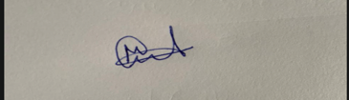  Name of the signatory: - Manasi Rajesh
To,
TheControllerof Patents,ThePatentoffice,Chennai

